NORTHERN IRELAND BOWLING ASSOCIATION
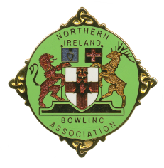
Junior (Under 25) Player Registration Form 2024

Name of Club: ______________________________

List of Club members who are under the age of 25 on 1 April 2024

Name
Date of
Birth
Contact
Number
Rink
Position
P/G
Y/N

Parental / Guardian consent has been obtained for those Players under 18 years.

Signature of Club Secretary: __________________________________

Return to: Honorary General Secretary
Henry McFarland
18 Abbington Manor
Bangor
BT19 1ZQ
Mob: 07703107579
Email: henry.mcfarland@btinternet.com

